AL-VAN IN HONOR / IN MEMORY PERSONALIZED PAW PRINTS
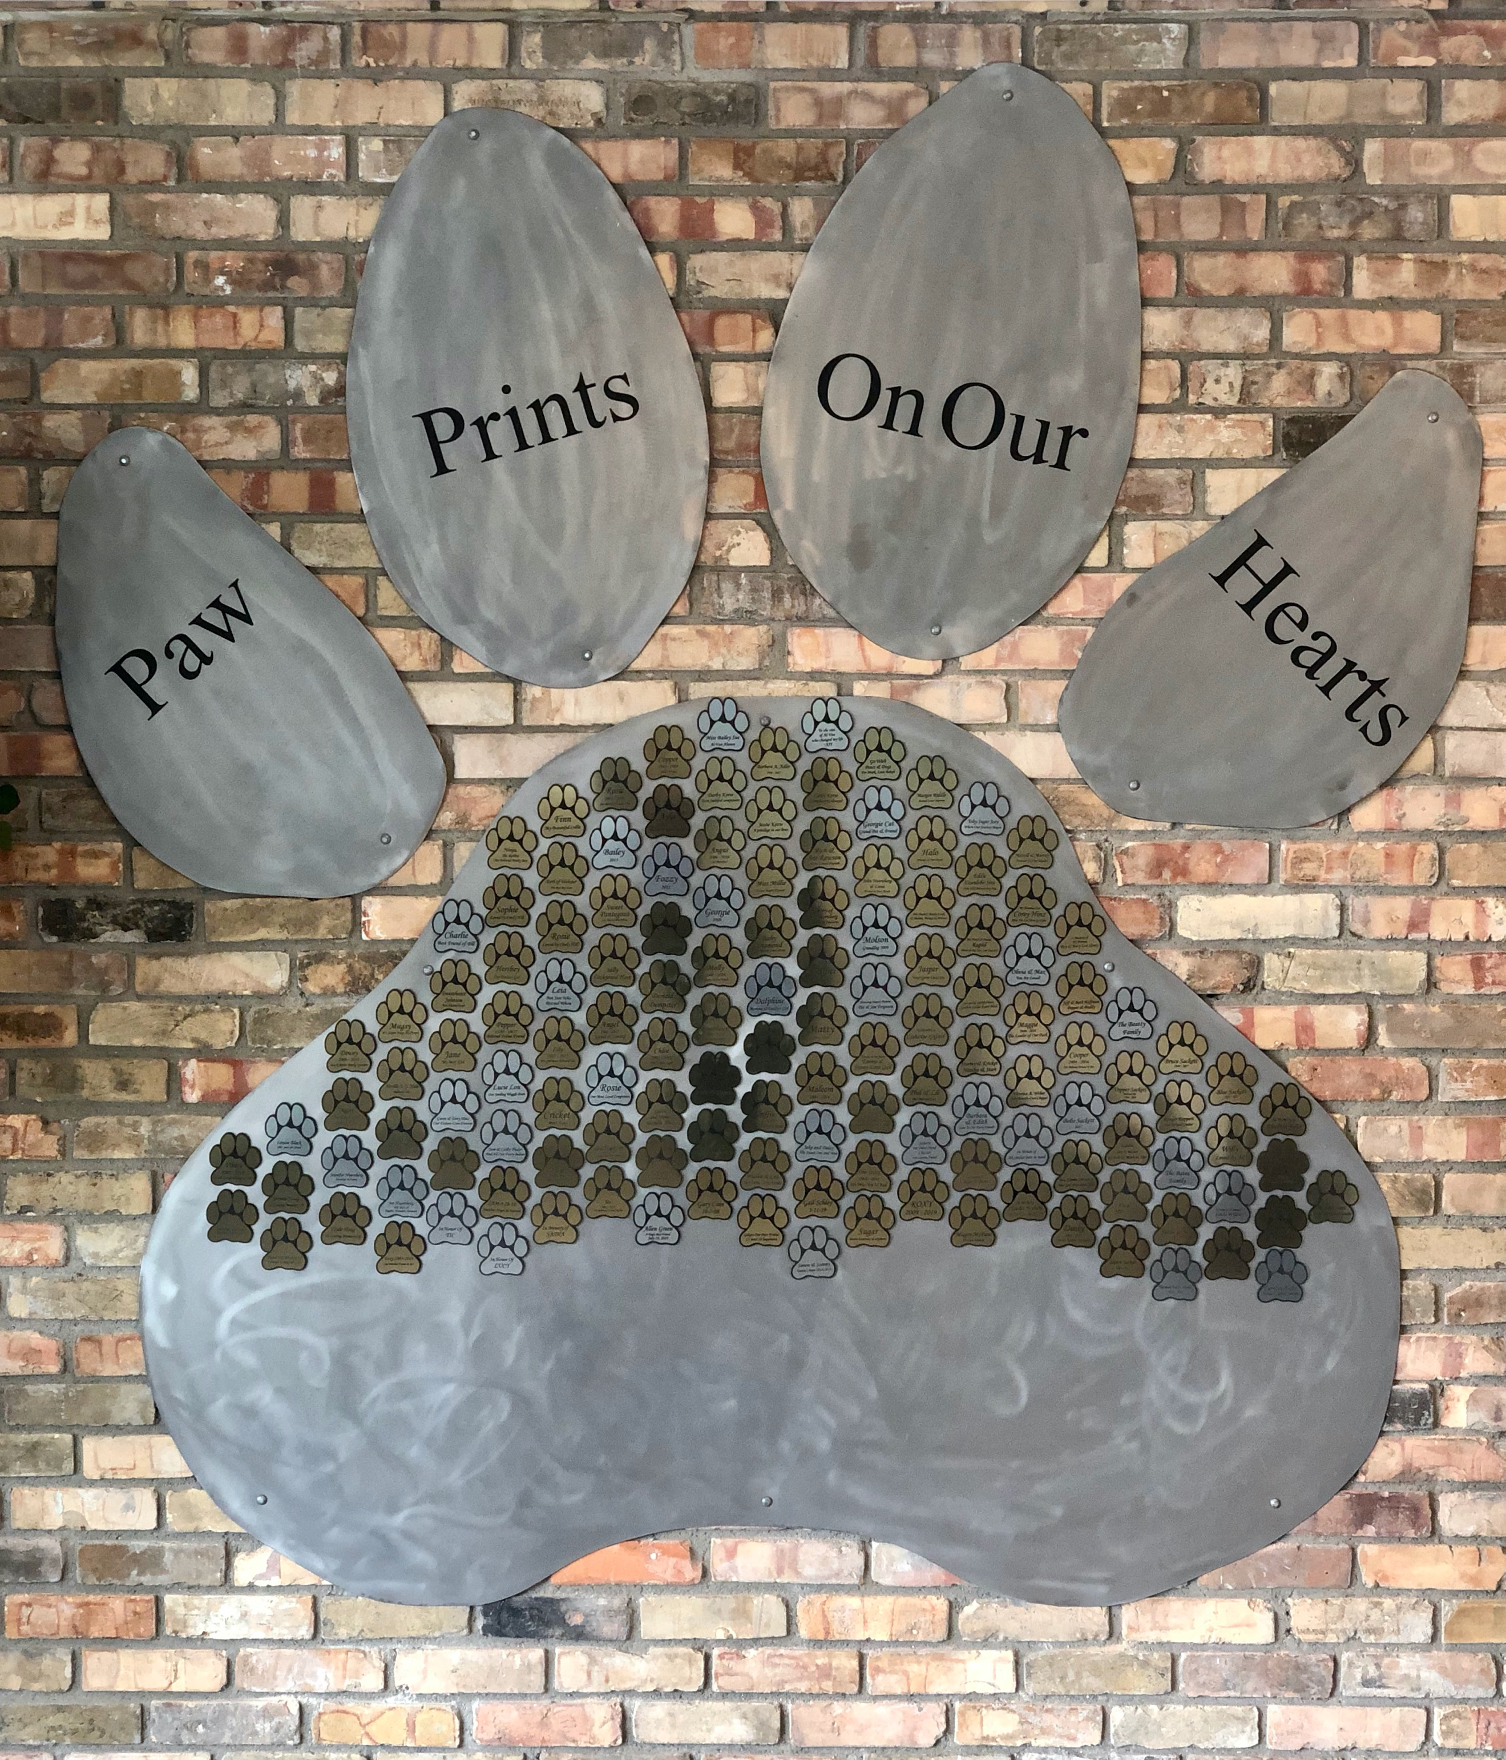
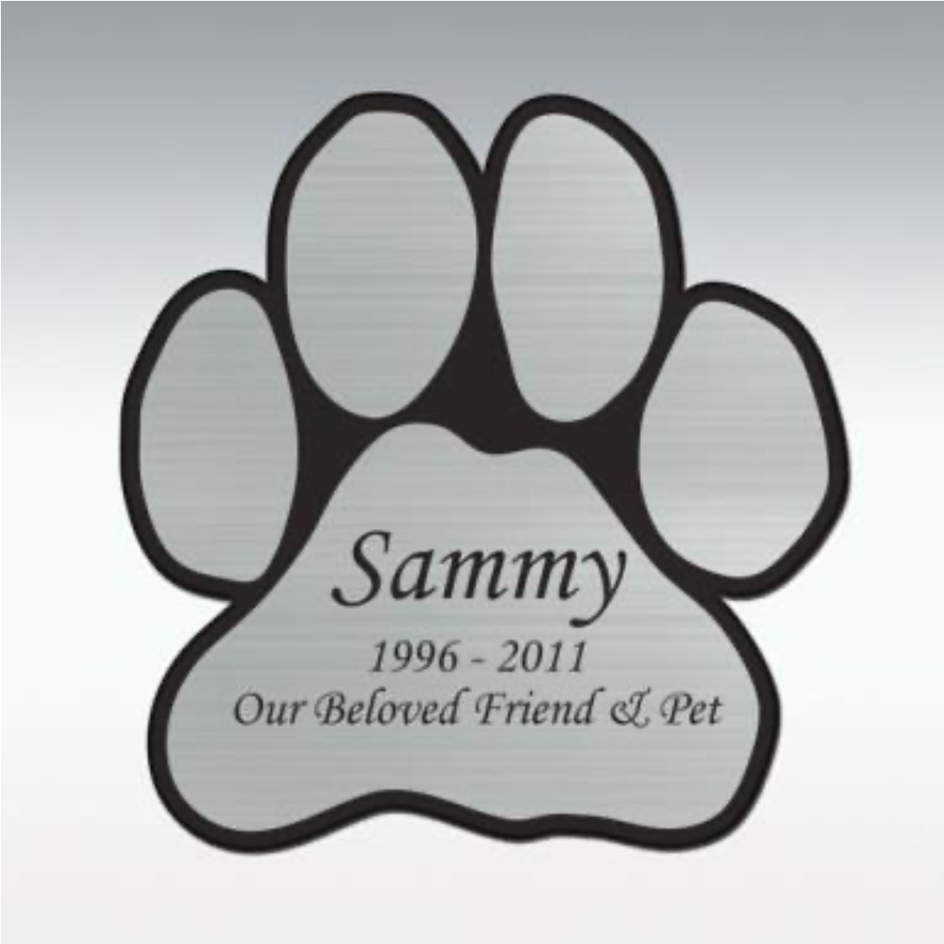
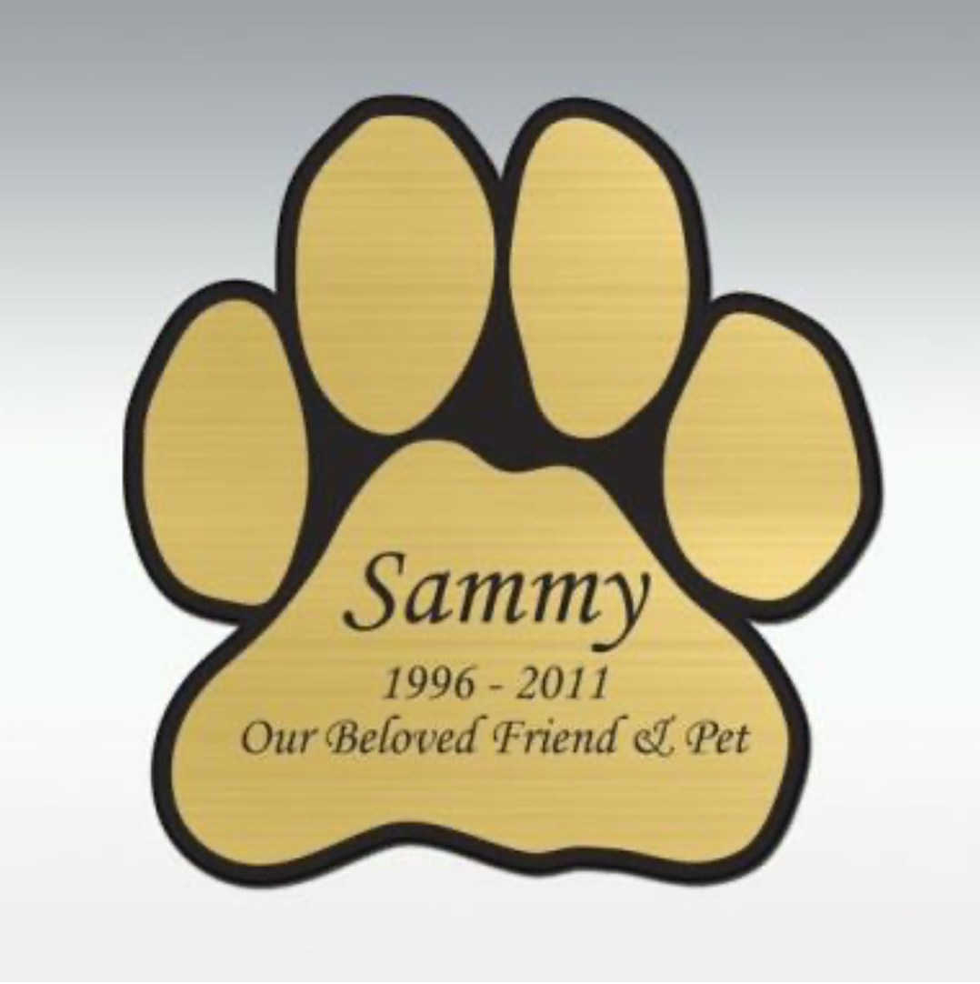

In Memory (Gold)
In Honor (Silver)

Leave your paw print in Al-Van’s Adoption Center Foyer. We have reserved space in the entryway to share your love for animals and donate $125 In Honor or In Memory of a four-legged friend who has touched your life, or honor someone whose passion for animal welfare has inspired you.

Your personalized Paw Print will hang in recognition of that pet or person, as well as your generous contribution to saving the lives of many more homeless, innocent, forgotten animals.

Plate Engraving
Customize your plate(s) with up to 2 lines of engraving. Each line can contain up to 25 characters (including spaces).

Please print:
Line 1_______________________________________________________________________________
Line 2_______________________________________________________________________________
Circle one: In Memory In honor

Payment options: $125.00 per Paw Print
Please make check payable to the Al-Van Humane Society and write “CARES” in the memo section.
Drop off to Al-Van’s Adoption Center or send to Al-Van’s mailing address: Al-Van Humane Society, PO BOX 421, South Haven, MI 49090
Call the shelter at 269-637-5062 if you would like to pay by credit card.

Your contact information:
Name________________________ Address_______________________________________________
Email______________________________________ Phone___________________________________

Person in memory/in honor of contact information:
Name________________________ Address_______________________________________________
Email______________________________________ Phone___________________________________

Al-Van Humane Society
Adoption Center: 07591 Blue Star Hwy, South Haven, MI 49090
Intake Center: 73303 8th Ave, South Haven, MI 49090
Mailing Address: PO Box 421, South Haven, MI 49090
269-637-5062 www.al-van.org

